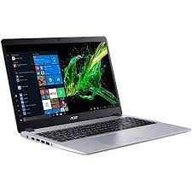

HP NOTEBOOK

* Intel Core I7-8565U
* 8 GB DDR4,
* 15.6″ Inch FHD
* 2GB GDR5 DDR4 1TB
* **Rs.110,000**